Cabernet Dorsa Barrique

Variety: Cabernet Dorsa

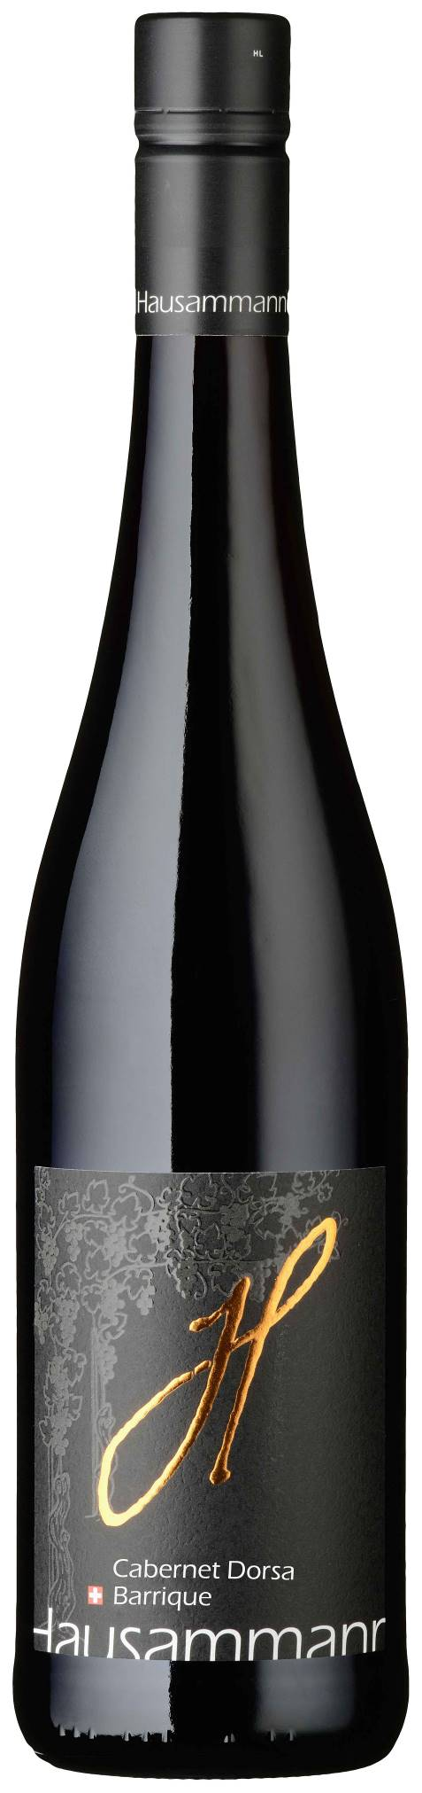
Provenance: Family Hausammann Iselisberg.
On the sunny southern slope of lower Thurtal.
The handcrafted grapes are obtained from own cultivation, gently processed in our cellar, carefully matured and bottled.

Colour: Dark cherry red with violet reflects.

Bouquet: Beautiful bouquet of ripe, dark forest berries and black cherries, with a hint of delicate spicy notes

Taste: Elegant, full-bodied cabernet note which matches perfect with delicate toast aromas. Well-developed fruit, ripe, dark berries. Well-integrated tannins with a peppery bouquet and lingering finish.

Vinification: Traditional mash fermentation. Matured for 12 months in Barrique.

Serving temperature / food recommendation:

18 ºC.

Ideal with hearty meat dishes, BBQ, Mediterranean food and spicy cheese or venison specialities.

