Pinot Noir Selection (“Auslese”)

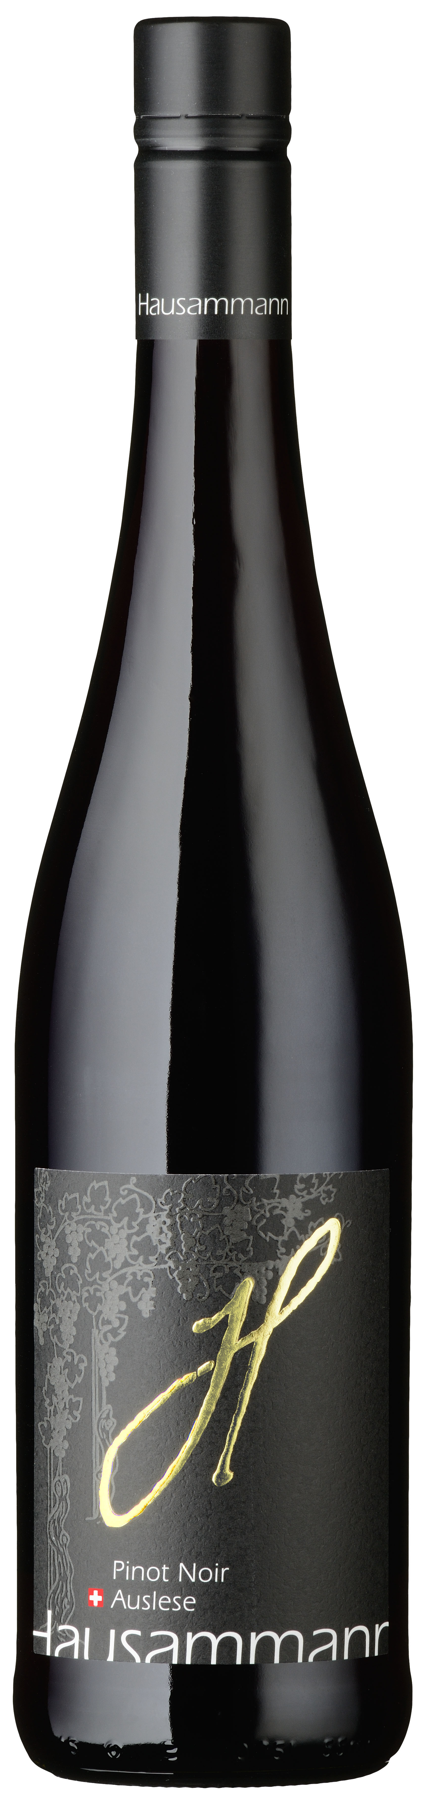Variety: Pinot Noir

Provenance: Family Hausammann Iselisberg.
On the sunny southern slope of lower Thurtal.
The handcrafted grapes are obtained from own cultivation, gently processed in our cellar, carefully matured and bottled.

Colour: Deep Ruby red.

Bouquet: Beautiful bouquet of red cherries, raspberries and cassis aromas.

Taste: On the palate, full-bodied fruity flavour of berries with well-integrated tannins and roast aromas. Well-structured, lingering, harmonious and elegant.

Vinification: Selected grapes of the later harvested vineyards. Traditional mash fermentation.

Serving temperature / food recommendation:

18 ºC.

Ideal with hearty meat dishes, cheese, grilled Chicken, venison and soy-based Chinese dishes.

